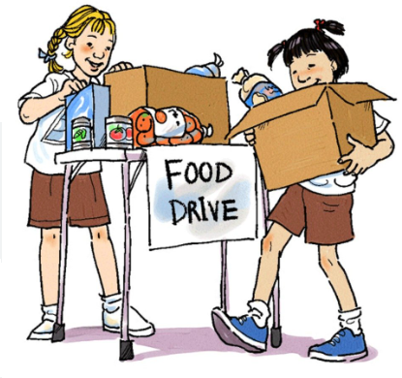
Have you thought about what foods a Food Pantry needs to help others?

North Dallas Shared Ministries is in its 40th year of helping people and one of the greatest needs is food.

NDSM could always use the following items:
Canned vegetables Beans (1–2-pound bags) Canned Fruit
Canned Chili Mac & Cheese (boxed) Canned Pasta (Spaghetti O’s)
Dry Pasta (elbow, Soups Tuna (5 oz cans)
Spaghetti, bowtie)
Peanut Butter (reg size)

If you would like to make a monetary donation you can send it to the address below.
Thank you for your kindness and generosity!

